**Software Project Management Plan**

Project: Exercise Education Website for U.S. Department of Education

February 28, 2021

Version 1.3

Jay Clute

Sydney Pearce

Derek Valentin

Isaac Ajiborode

Dagm Kebede

Emmanuel Azike

Revision History

**Document History**

**Version Date Reason for Change**

1.0 02-28-2021 Creating first version of SPMP

1.1 04-25-2021 Added deliverables and organization

1.3 04-27-2021 Updated work structure

Preface

The following Software Project Management Plan (SPMP) describes the proposed plan to be taken by Group 1 to complete the design and implementation of a working demo of the Exercise Education Website for the U.S. Department of Education according to the requirements specified by the client.

As such, the scope of this project includes all design and implementation by the team in order to get a functioning demo running by May 2021.

The SPMP is intended to be used by the U.S. Department of Education for the purpose of evaluating Group 1’s response and ideas to the proposed project requirements. Should Group 1’s response be accepted and chosen by the U.S. Department of Education to deliver the product, the SPMP shall also be used by Group 1 as a plan and guide for conducting the product, as well as a reference to project plans and processes.

Table of Contents

Title Page………………………………………………………………………………………….1

Revision History…………………………………………………………………………………..2

Preface……………………………………………………………………………………………..3

Table of Contents..………………………………………………………………………………...4

List of Figures……………………………………………………………………………………..5

List of Tables………………...…………………………………………………………………….6

1. Introduction…………………………………………………………………………………..7-9

1.1 Project Overview……………………………………………………………………...7

1.2 Project Deliverables…………………………………………………………………...8

1.3 Evolution of the SPMP………………………………………………………………..8

1.4 Reference Materials…………………………………………………………………...9

1.5 Definitions and Acronyms…………………………………………………………….9

2. Project Organization………………………………………………………………………...9-11

2.1 Process Model…………………………………………………………………………9

2.2 Organizational Structure………………………………………………………..……10

2.3 Organizational Interfaces………………………………………………………….....10 2.4 Project Responsibilities……………………………………………...………….……11

3. Managerial Process…………………………………………………………..………….....11-12

3.1 Management Objectives and Priorities………………………………………..……..11

3.2 Assumptions, Dependencies and Constraints………………………………………..11

3.3 Risk Management……………………………………………………………………12

3.4 Monitoring and Controlling Mechanisms……………………………………………12

4. Technical Process………………………………………………………………………….13-14

4.1 Methods, Tools and Techniques……………………………………………………..13

4.2 Software Documentation………………………………………………….…………13

4.3 Project Support Functions………………………………………………….…….13-14

5. Description of Work Packages………………………………………………………….….…15

5.1 Work Breakdown Structure (WBS) …………………………………………………15

5.2 Dependencies Between Tasks…………………………………………………….….15

List of Figures

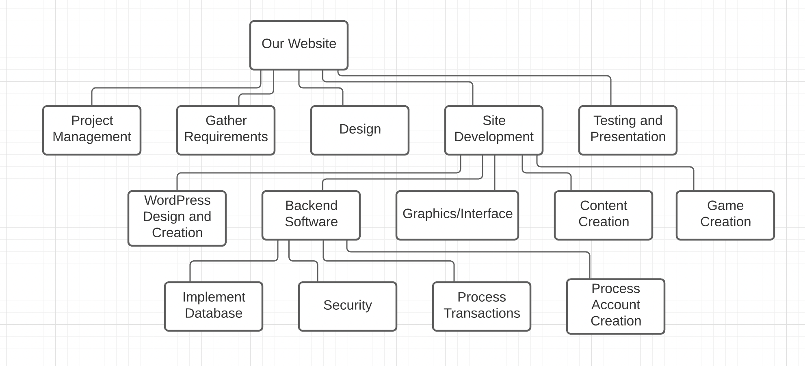

List of Tables

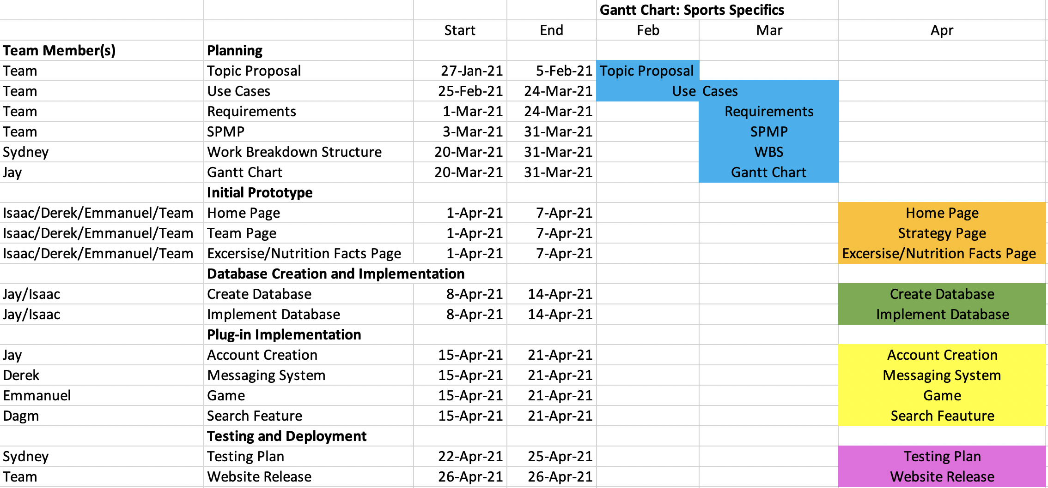

**1. Introduction**

1.1 Project Overview

Executive Summary:

The purpose of this project is to create a website for the U.S. Department of Education that educates children and young adults on the importance of exercise and nutrition. The website will be designed with a focus on student athletes, but will not be limited to only student athletes. The main concept of this website will be a game that educates the user on exercise, nutrition, etc. There will be many other functions to this website to make it more practical than just a gaming website. Students will be able to join teams, message friends, search for local gyms, hire personal trainers, and purchase workout plans or diet plans from trainers. Parents, coaches, and trainers can also create accounts on the website in order to monitor their child’s progress, talk and organize their team, and offer their services respectively.

1.2 Project Deliverables

1. Preliminary Project Plan 02.05.2021

2. Requirements Specification 03.10.2021

3. SPMP 03.31.2021

4. Initial Prototype 04.07.2021

5. Database Creation and Implementation 04.14.2021

6. Account Creation 04.21.2021

7. Messaging System 04.21.2021

8. Game 04.21.2021

9. Search Features 04.21.2021

3. Analysis [Object model, Dynamic model, and User interface] 04.22.2021

4. Architecture Specification 04.22.2021

7. Test Plan 04.23.2021

8. Final Product w/ Demo 04.26.2021

1.3 Evolution of the SPMP

This document will be updated as the project progresses. Updates should be expected in the following sections:

**i.** ***References*** - updated as necessary

**ii.** ***Definitions, acronyms, and abbreviations*** - updated as necessary

**iii.** ***Organizational Structure*** will be updated as the team leaders are assigned for each phase.

***iv.*** ***Technical Process -*** This section will be reviewed appropriately as design requirements and decisions become clearer.

**v.** ***Schedule –*** as the project progresses, the schedule will be updated accordingly

1.4 Reference Materials

* [High School Sports Online - Stream Live & On Demand (nfhsnetwork.com)](https://www.nfhsnetwork.com/)
* [Maryland Public Secondary Schools Athletic Association | MPSSAA](https://www.mpssaa.org/)
* [High School Esports League | HSEL](https://www.highschoolesportsleague.com/)

1.5 Definitions and Acronyms

* **URD** - User Requirements Document
* **SPMP** Software Project Management Plan (this document)
* **APM**-Adaptive project management
* **TBD-**To be determined or decided.

**2. Project Organization**

2.1 Process Model

The project will be using a management model called APM

(Adaptive project management). It is a structured and systematic process that allows you to gradually improve your decisions and practices, by learning from outcomes of the decisions that you took at previous stages in the project. Therefore, it is possible that we edit our requirements as we progress through the project.

2.2 Organizational Structure



2.3 Organizational boundaries and interfaces

Team leaders throughout each development of the phases will be responsible for coordinating team meetings, updates, communications, and team deliverables. Relations with other entities include meetings in order to check up and get feedback on desired changes. These “check-up meetings” will also allow the client and team the ability to communicate any changes or updates that arise.

2.4 Project Responsibilities

For the most vital responsibilities per phase of each team member, please refer to segment 2.2. Ultimately the whole complete development of the project team is responsible for the successful delivery of the product. The team member tasks per deliverable according to expertise and the phases below:

1. Project Plan – Whole Team

2. Requirements Specification – Whole Team

3. Analysis – TBD

4. Architecture Spec – TBD

5. Component/Object Specification – TBD

6. Source Code – TBD

7. Test Plan – TBD

8. Final Deliverable – Entire Team

**3. Managerial Process**

3.1 Management Objectives and Priorities

* Keeping up with internal deadlines to ensure the project is completed by the client’s deadline
* Organize meetings with the client in order to keep the client informed of the progression of the project as well as receive feedback
* Create and update project documentation of requirements, planning, tools, risks, cost analysis, and any anticipated or unanticipated changes
* Upon deployment, testing the site continually to maintain top performance and functionality

3.2 Assumptions, Dependencies, and Constraints

The project depends heavily on developing a high level understanding of WordPress in a limited amount of time. Success of the website depends solely on every group member contributing to their role. Constraints include, but are not limited to, time and money. Every group member will have to be present at every designated meeting time.

3.3 Risk Management

In order to account for risk management we will meet with our client (the professor) and show her the working process of the website to see if there's any changes needed to be made. Weekly team meetings will be held in order to account for any changes in the project’s integrity.

3.4 Staffing Plan

We are fortunate to already have our team fully staffed. Each team member already serves an important role in the development of the project, so we will not need to add any more staff members to this project.

3.5 Monitoring and Controlling Mechanisms

Constraint: There is no funding for this project

Contingency: We will have to be mindful to only use tools that are cost efficient and free. We will also have to ensure that we split all costs evenly.

Constraint: The backend developers have not used MySQL before

Contingency: The backend developers will go through extensive tutorials and walkthrough videos to get acquainted with the tool.

Constraint: The website must have a working demo by April 26th, 2021

Contingency: Each team member must be aware of the deadlines in order to ensure that the project progresses at an appropriate pace. If one team member is struggling with their task, other team members will help out in order to keep the project from stalling.

**4. Technical Process**

4.1 Methods, Tools, and Techniques

WordPress

HostGator

Json for interaction

4.2 Software Documentation

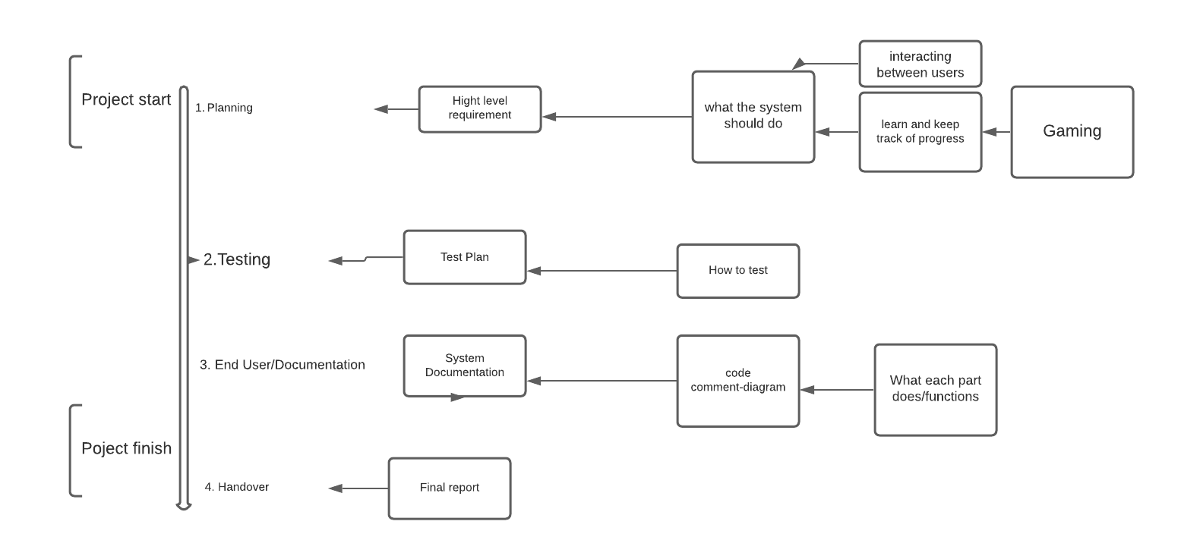

4.3 Project Support Functions

Ensure the agreed project management methods, standards and processes are maintained throughout the project lifecycle.

* Assist the Project Manager and Team Managers in the production and maintenance of project plans.
* Develop and maintain the project library, filing, recording and reporting systems.
* Develop and implement appropriate configuration management procedures
* Coordinate the production of all reports and produce project summary reports.
* Set up and maintain systems for recording project costs.

1. Identify the goal of the website: create an environment where students,parents and coaches can coexist. A place where students can track their progress while working out and playing games.
2. Scope definition: the website requires a front page (sign up page/ log in) with a little of overview

Students section

Parents section

Coaches section

Game section

Sign Up section

1. Content creation: Main focus of the page for Exercise Education Website for the U.S. Department of Education
2. Testing: Deployed weekly
3. Launch: Final product 5/17/21

**5. Description of Work Packages**

5.1 Work Breakdown Structure (WBS)



5.2 Dependencies Between Tasks

Planning of requirements for LivingActively depended directly on scheduled meetings every Monday at 7:00 PM between group members. Actual deployment of website and development depended heavily on management and requirement gathering. In order to develop our back end we had to create a host through HostGator for our then created blank WordPress site. Using the back end we can then create the front end for styling purposes. The back end requires heavily on the implementation of a database for storing user information. Processing transactions on the website requires a secure platform. Actual deployment of the website depended on all group members contributing to their role.